**Silverlight db specifications**

**(Correct as at 31/03/2016)**

**By Alan Thompson**

**Technology and locations**

1. Front-end:Silverlight

(do not upgrade no need as should be developed easily in ASP.net/MVC/C# or other system from ICT).

1. Front-end Location <http://ohgreports:999/surveys.aspx#/SetupSurvey>

See here how to search for a resident and then click which survey to carry out.

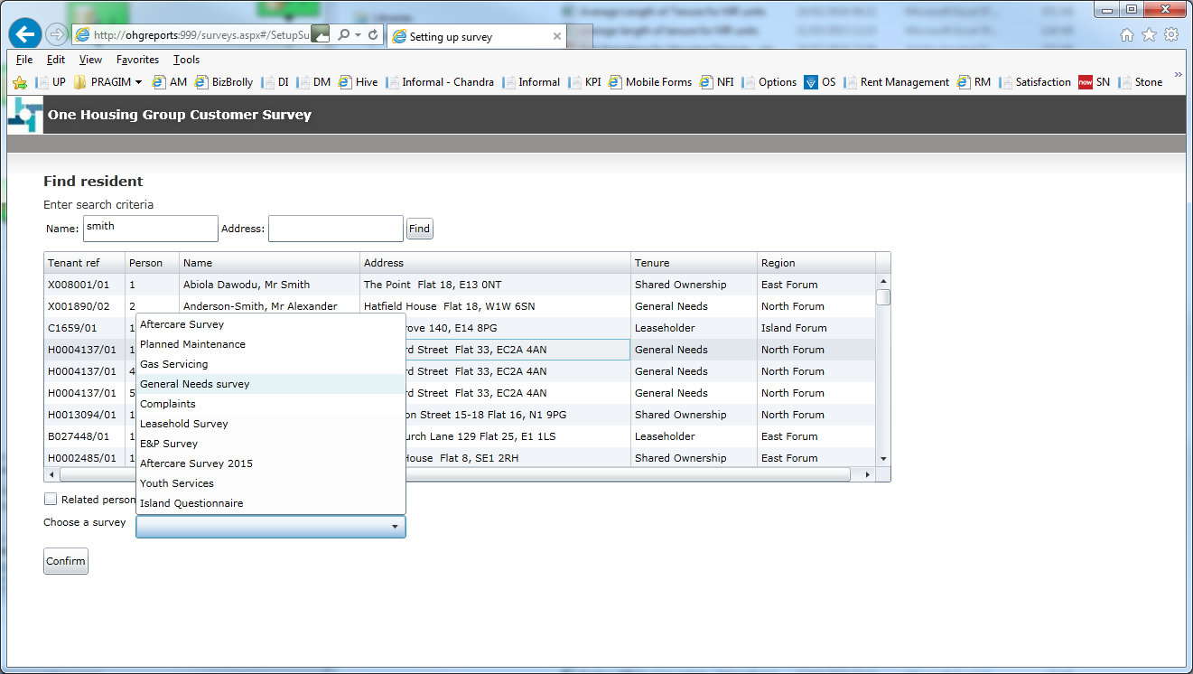

1. Back-end: Sql Server > ohg2k5sql01 > survey > all tables in this db as sole for this use

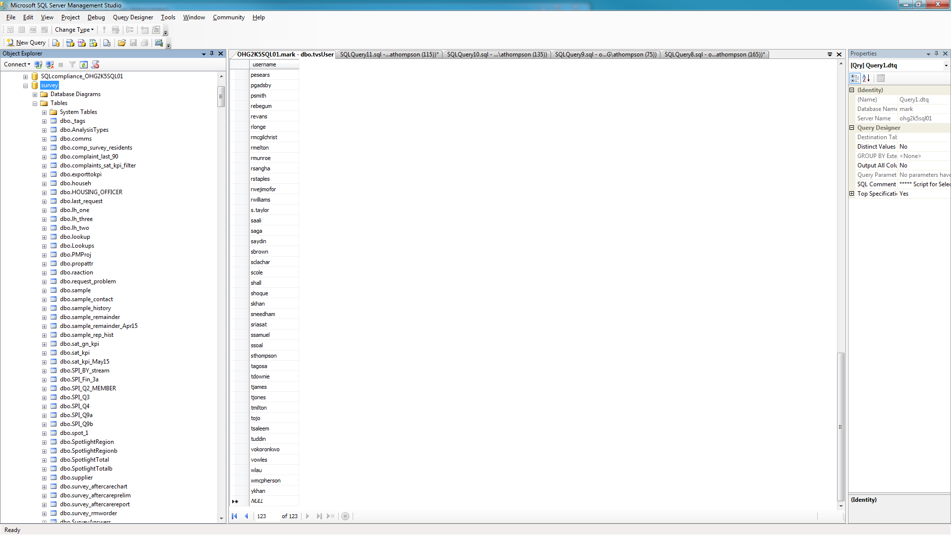

Main tables you need are:

3.1) SurveyInstances – this is the main ‘single’ record for as survey that has been carried out, important for when it was done, who did it , what type and the UH tenant ref – to related to other systems.

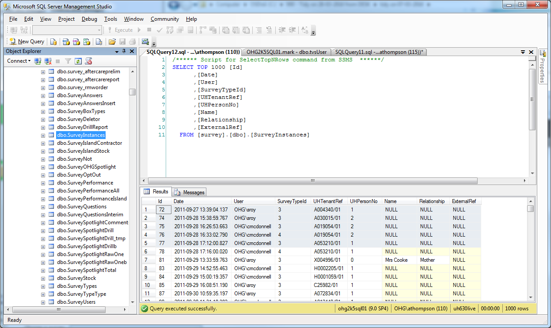

3.2) SurveyAnswers – the main table to store the form answers from Silverlight, important for KPI.

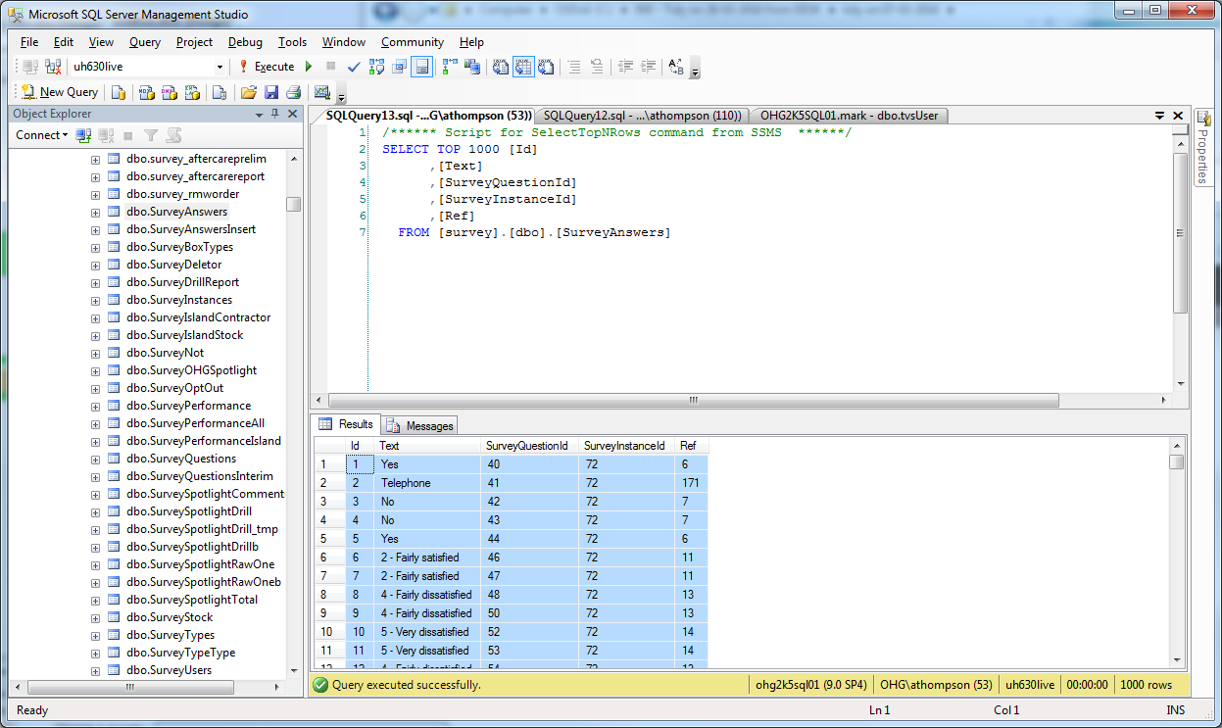

3.3) SurveyQuestions – Defines the questions for the survey:

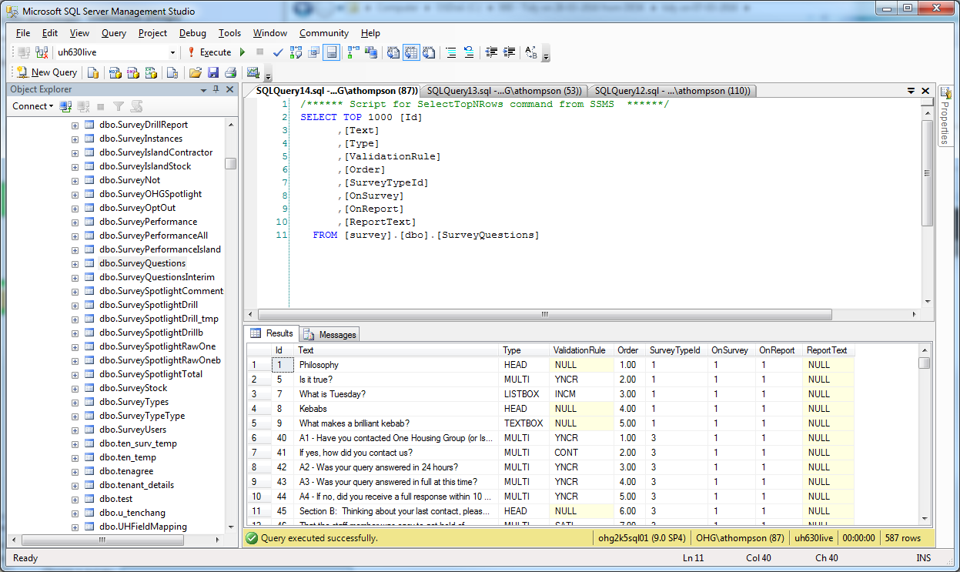

1. User setup

Whilst the team have a self service tool and so should have eliminated any actual need to have ICT add users now. It has a bug and will fail when user exists – if they don’t check. Users may email you or the Sn or ICT helpdesk, or call them and be referred to you. This is a support matter really and so helpdesk should do it by using the self service tool (if fixed or if checked if exists first)

Tool: <http://ohgdwdev01/Survey/Admin.aspx>

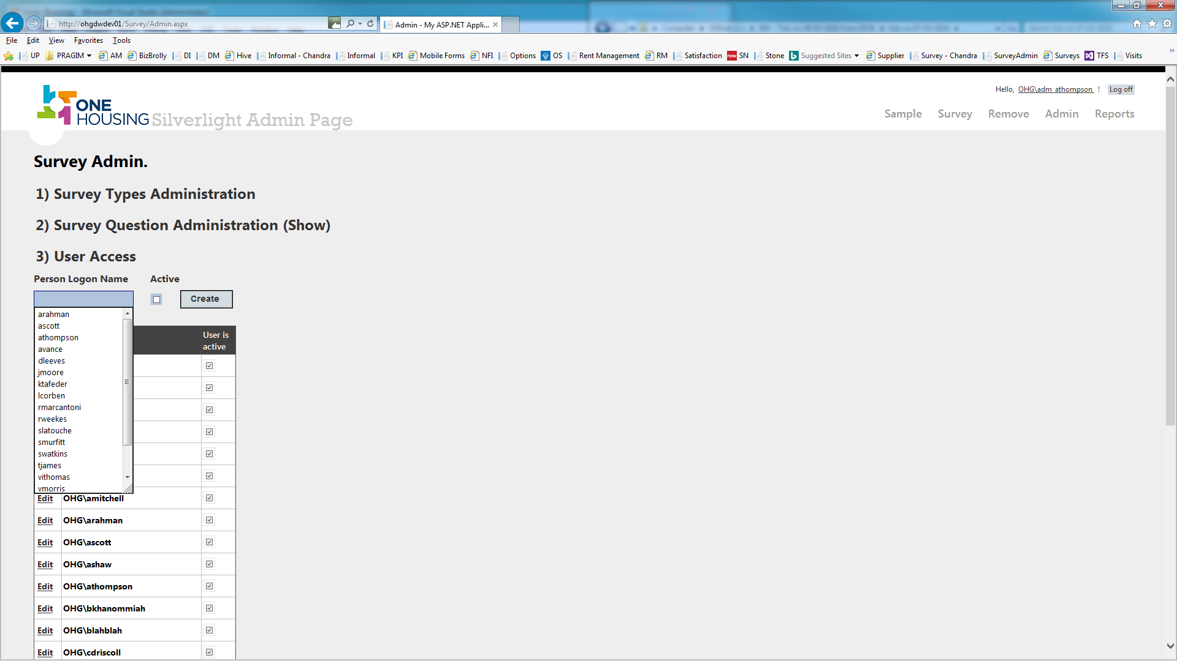

Or just by updating the sql table directly:

7.1) first check the user does not already exist

7.2) then if they DO NOT, you can add them. The user_name which is in the ‘login’ field is a PK or at least must be unique, so duplicates are not allowed hence the self service failure reasons. If they can be added, right click the SurveyUsers table as shown here, to edit the table.

Then whilst in edit, type in the user_name – ie ohg\athompson (There is no id automatic/identity) and ensure you make ‘active’ to be True – or False to deactivate someone later. Unlike the complaints access db, this one does NOT need full details if possible add them, but it is not mandatory, ensure no matter what that login is added (most important or they CANNOT use the db via the SSO) , name, title, email – for admin purposes by the team. The other fields such as readonly, active and admin are self explanatory.

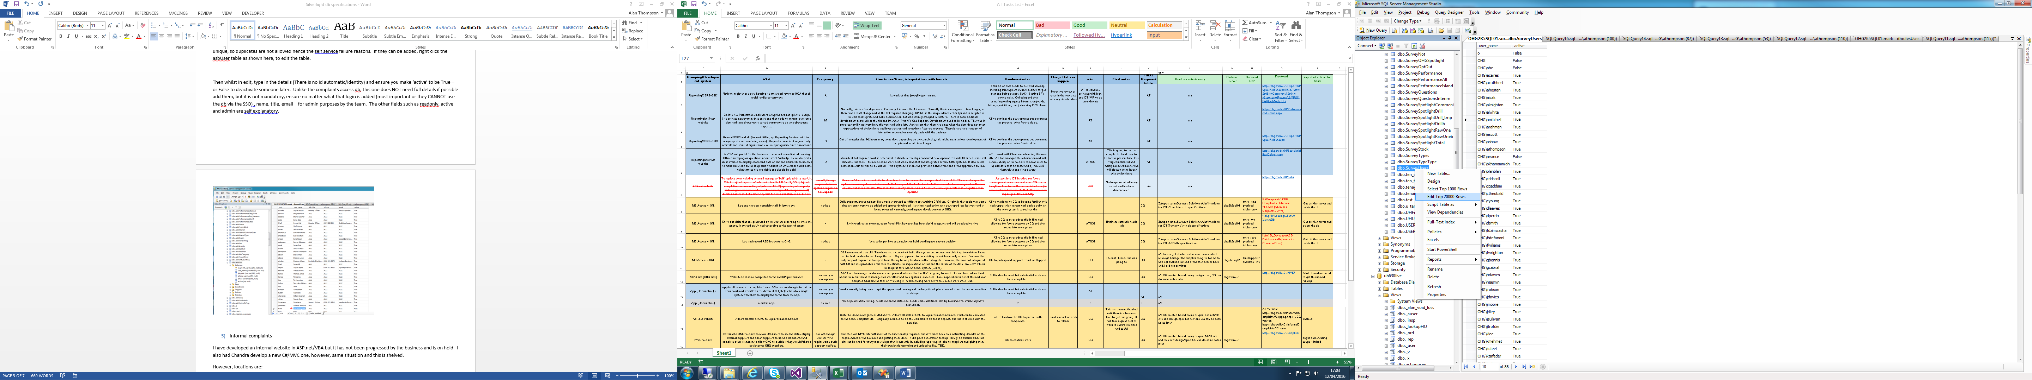

1. Self Service Tool: <http://ohgdwdev01/Survey/Admin.aspx>

Although loathe to let just anyone do this as the question can become the KPI, so it has to be carefully used, also we don’t want the users just creating any old form as this has likelihood to lead to confusion and duplicative forms.

It does however let you add types:

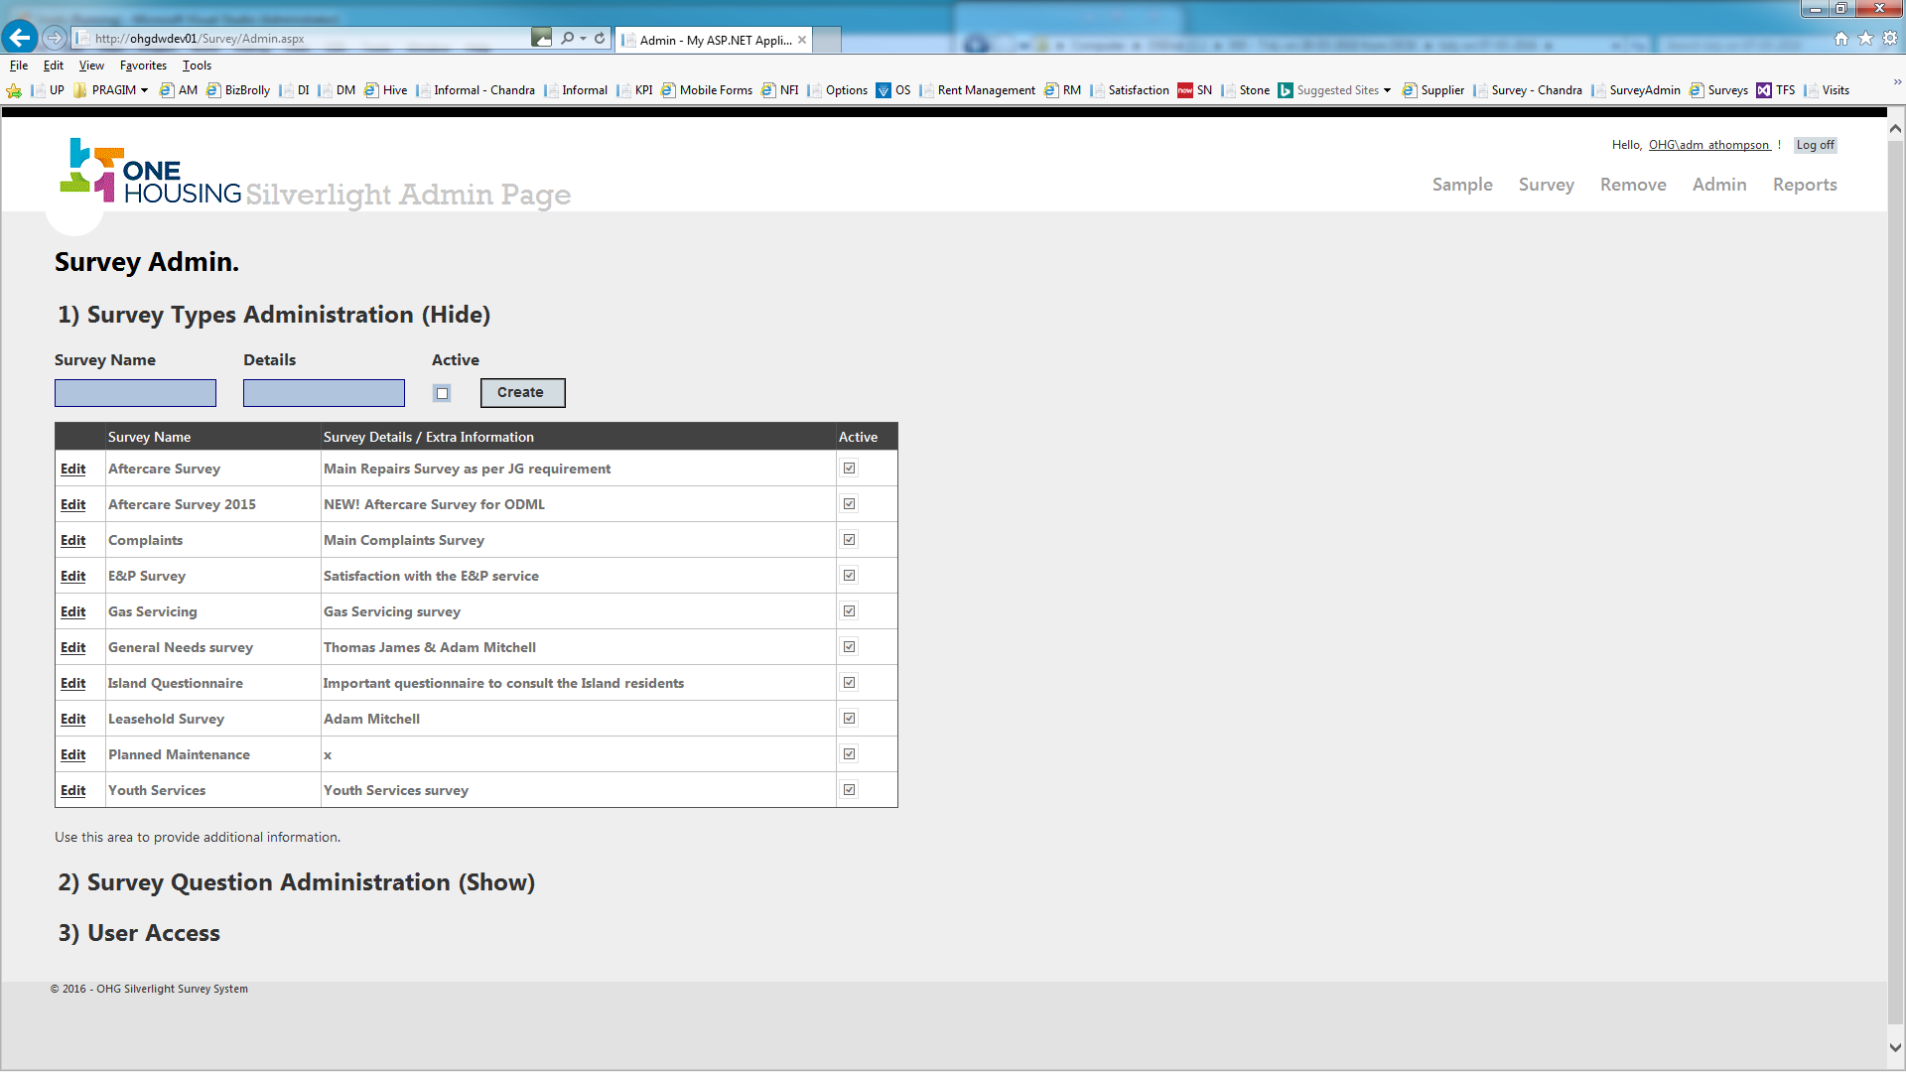

Then once type is added, the relevant questions for the form:

